IS YOUR HOME SAFE FROM FIRE?
Suffolk Fire and Rescue Service
Please contact us if you:
- Have concerns
over fire safety in your home
- Do not have working smoke alarms
- You cannot hear your alarms at home
Safer Home Visit
A free visit by a specialist Prevention
Practitioner, Community Fire Volunteer or Operational crew
SFRS Prevention team and Firefighters are dedicated to saving lives by working with the community , discussing fire safety and offering advice to eliminate or reduce the risk of a fire occurring in the home. Free smoke alarms will be fitted if you do not have any.

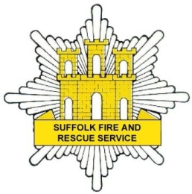
Customer feedback,
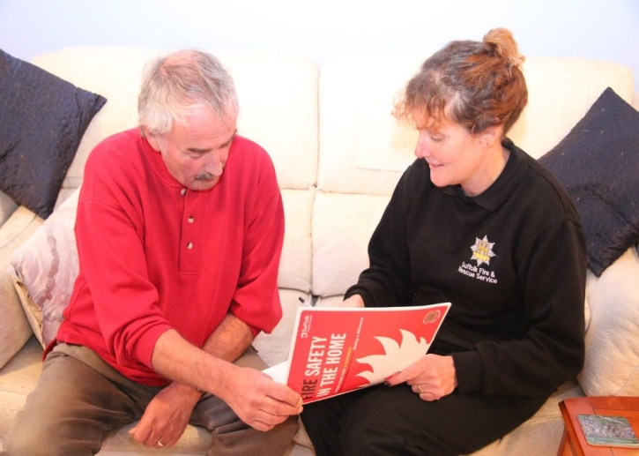
Mrs B has phoned in to pass her thanks on to your practitioner for a very helpful Safer Home Visit. Mrs B said the service was
excellent, efficient, and feels far more
safe after the visit.
Call Fire Business Support 01473 260588

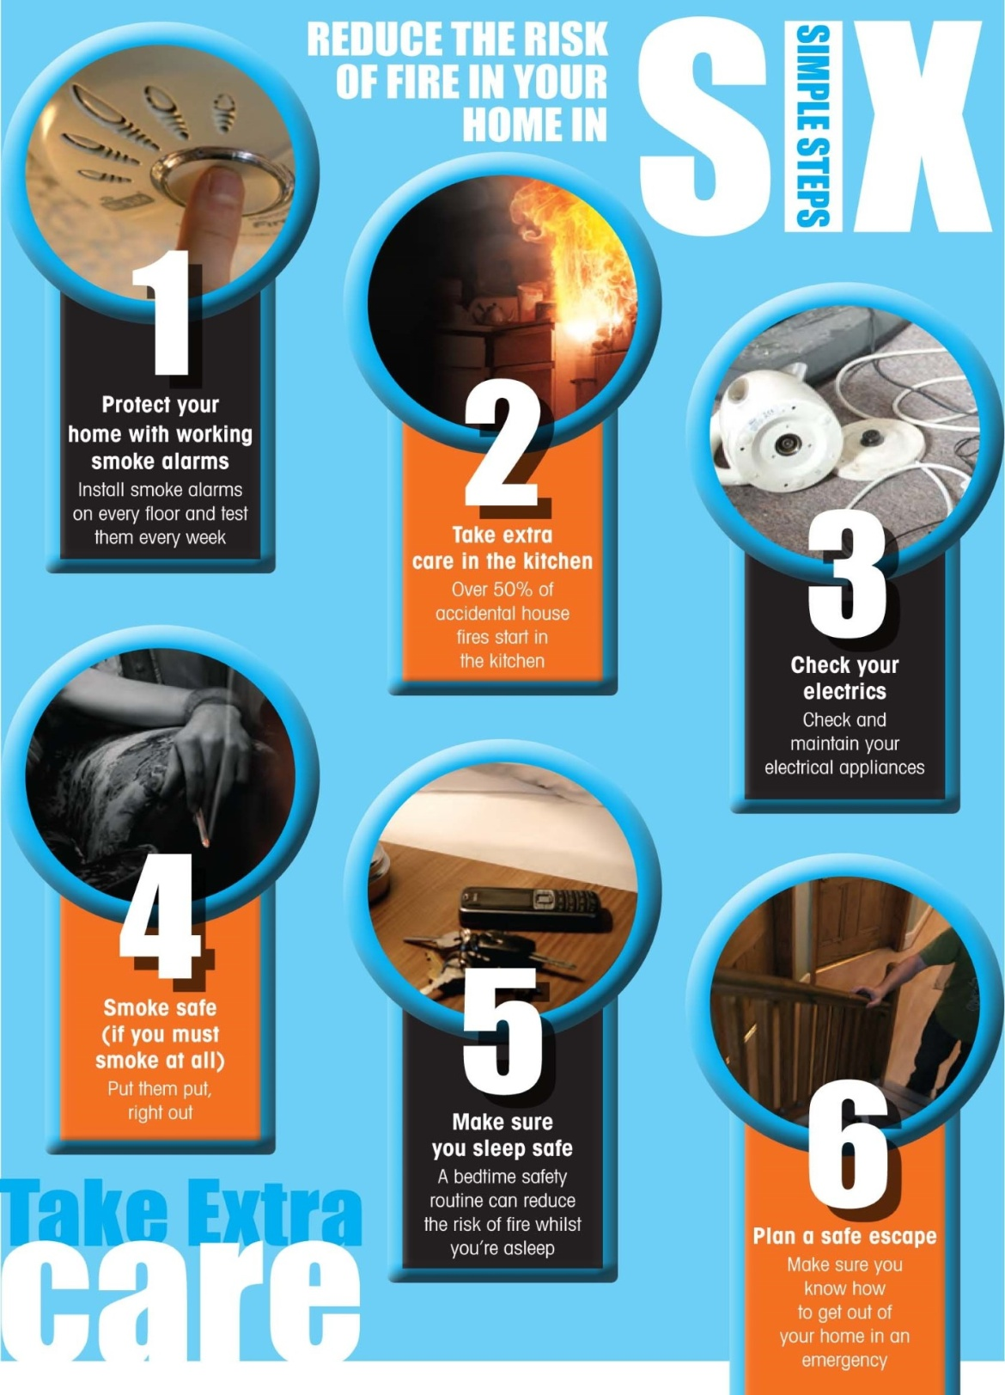
Call Fire Business Support 01473 260588

